# DECLARATION

This internship report is my original work and has not been submitted elsewhere for graduation.

*Signature ………………………………Date……………..*

*ISHIMWE ELODIE*

*06-140*

# APPROVAL

This internship report has been submitted for presentation with the approval of the Supervisor.

Signature………………………………………………. Date ……………………………………………………

# DEDICATION

I dedicate this work to all those who are dear to me :

My parents ;

My brothers and sisters ;

My friends (All).

# ACKNOWLEDGEMENT

At the end of this work, I thank the good God Almighty who looked after me and who allowed me to arrive to this day.

I also thank my parents who supported me and gave me all that was necessary for me to study and have an excellent education.

My gratitude also goes to MSc Amédée KWIZERIMANA, my academic supervisor who helped and guided me during the realization of this report, for having accepted to supervise this work, and for all his assistance.

I would like to thank the President and the members of the jury who agreed to read and evaluate my work and to participate in its assessment.

I also thank all the professors who have taught me from elementary school to university, especially those of the IT faculty at BIU University for their scientific training.

My thanks also go to my classmates, with whom we shared the training, thank you for all the help provided.

Finally, to all my relatives, friends and all people who contributed to my studies, I say thank you, GOD BLESS YOU.

# ABBREVIATIONS AND ACRONYMS

|  |  |
| --- | --- |
| **AJAX** | : Asynchronous JavaScript and XML |
| **BIU** | : Bujumbura International University |
| **CPU** | : Central Processing Unit |
| **CSS** | : Cascading Style Sheets |
| **DOM** | : Document Object Model |
| **GB** | : Giga Byte |
| **HTML** | : HyperText Markup Language |
| **IT** | : Information Technology |
| **JSON** | : JavaScript Object Notation |
| **PHP** | : Hypertext Preprocessor |
| **SQL** | : Structured Query Language |
| **UML** | : Unified Modeling Language |
| **W3C** | : World Wide Web Consortium |
| **WAMP** | : Windows Apache MySQL PHP |
| **XHTML** | : eXtensible HyperText Markup Language |
| **XML** | : eXtensible Markup Language |
| **XSLT** | : eXtensible Stylesheet Language Transformations |

# LIST OF TABLES

Table 1 : System actors and their roles 20

Table 2 : Nominal scenario of add property use case 21

Table 3 : Nominal scenario of add register use case 21

# LIST OF FIGURES

Figure 1 : Organizational structure of UFANISI ICT 8

Figure 2 : Use case diagram 19

Figure 3 : Class diagram 22

Figure 4 : Activity diagram Login 23

Figure 5 : Activity diagram for add property use case 24

Figure 6 : Home Page : search section 29

Figure 7 : Home Page : Latest properties section 30

Figure 8 : House details (1) 31

Figure 9 : Property details (2) 32

Figure 10 : Property details (3) 32

Figure 11 : Property details (4) 33

Figure 12 : Login 34

Figure 13 : Dashboard 35

Figure 14 : Pending property 36

Figure 15 : House publication 36

Figure 16 : User Management interface 37

Figure 17 : New property form 38

Figure 18 : Property list 38

Figure 19 : Message page 39

Figure 20 : Offer page 39

Figure 21 : Accept booking modal 40

Figure 22 : Rental offer form 40

Figure 23 : Check offer status page 41

Figure 24 : Favorites pages 41

Figure 25 : Profile settings 42

TABLE OF CONTENTS

DECLARATION i

APPROVAL ii

DEDICATION iii

ACKNOWLEDGEMENT iv

ABBREVIATIONS AND ACRONYMS v

LIST OF TABLES vi

LIST OF FIGURES vii

CHAPTER I. GENERAL INTRODUCTION 1

I.1. Training plan reference and linkage to the internship 1

I.2. Reason for doing this internship 2

I.3. Nature of the company where the internship was carried out 2

I.4. Reason to choose UFANISI ICT as internship Host Company 2

I.5. Main Activity of the enterprise 2

I.6. Outline of the internship report 3

CHAPTER II. DESCRIPTION OF UFANISI ICT 4

II.0. Introduction 4

II.1. History of the Company 4

II.2. Geographical location of the Company 4

II.3. Vision of the Company 4

II.4. Mission of the Company 4

II.5. Objectives of the Company 5

II.6. Value of the Company 5

II.7. Future prospects of the Company 6

II.8. Services/Products offered by the Company 6

II.9. Company organization chart 8

CHAPTER III. INTERNSHIP PROGRESS : ANALYSIS AND DESCRIPTION OF THE ACTIVITIES 9

III.1. Presentation of the reception service and planning of activities 9

III.2. Description of the activities performed 10

III.2.1. Testing applications 10

III.2.2. Marketing or advertising 11

III.2.3. Training 11

III.2.4. Establishing client’s specifications document 11

III.3. Correlation between the theoretical courses and the reality on the ground 12

III.4. Description of the observed problem 13

III.5. Analysis and criticism of the existing system 14

III.6. Proposed solutions to the problem 16

CHAPTER IV. MODELING OF THE PROPOSED SYSTEM WITH UML AND PRESENTATION OF THE DEVELOPED APPLICATION 17

IV.1. Introduction 17

IV.2. Explanation of the choice of UML 17

IV.3. Advantages of UML 17

IV.4. Abstract of certain diagrams 18

IV.4.1. Use case diagram 18

IV.4.2. Class diagram 18

IV.4.3. Activity diagram 18

IV.5. Modeling of the proposed system 19

IV.5.1. Presentation of the use case diagram 19

IV.5.2. Textual description of the use cases 20

IV.5.3. Presentation of the class diagram 22

IV.5.4. Presentation of Activity diagram 23

IV.6. Application presentation 25

V.6.1. Used tools 25

IV.6.2. Description of the user interfaces 29

IV.6.3. Advantages of the application 42

CHAPTER V. GENERAL CONCLUSION AND SUGGESTIONS 43

V.1. GENERAL CONCLUSION 43

V.1.1. Critical appreciation of the progress of the internship 43

V.1.2. Critical assessment of the observed problem 43

V.2. SUGGESTIONS 44

REFERENCES 45

# CHAPTER I. GENERAL INTRODUCTION

## I.1. Training plan reference and linkage to the internship

During my training in class, I’ve learned courses like software engineering, modeling languages MERISE AND UML, Web programming Level 1 and Web programming Level 2, project management and many others.

All those courses mentioned, I got chance to see how I can use them in practical way in the company where I did my internship.

I learnt how to define the needs of the client when he wants a software, establish “cahier des charges”, a document where we write all the needs of the client, which is related on the notion learned in the course of software engineering where we learned how a software is built, steps to follow from defining the needs, design and modeling, development, to its deployment.

System modeling is the process of developing abstract models of a system, with each model presenting a different view or perspective of that system. It is about representing a system using some kind of graphical notation.

During my internship, I experienced the use of UML language in modeling a system which is an important step, as it’s where we define how the system will work and how it will interact with users.

Most programming languages used in the company where I did my internship are : PHP for the backend side and HTML, CSS, JAVASCRIPT for the frontend. All those languages, I have seen them in courses mentioned above, HTML and CSS in Web programming Level 1, and PHP in Web programming Level 2.

Put into practice the concepts learned in class was a good experience for me as I saw how courses learned could be benefit in solving problems in real life in IT world.

## I.2. Reason for doing this internship

The reason for doing my internship was to be able to see how lessons learned in class can be used, being helpful in solving problems in a company, acquire new skills, and gain much experience.

## I.3. Nature of the company where the internship was carried out

UFANISI ICT is a limited company. LTD companies are privately owned, which means for anyone to purchase or own shares, and therefore be part of the business, they must have approval from company directors and other shareholders.

## I.4. Reason to choose UFANISI ICT as internship Host Company

Among all companies that produce management systems here in Bujumbura, I have chosen UFANISI ICT Solutions and Research (Bu) LTD because firstly they offer systems which are Web based and for me it’s important as I’m projecting myself more in Web development, and also because their systems bring solutions in different domains like hospitals, hotels, stores, supermarkets, human resources, universities and schools.

## I.5. Main Activity of the enterprise

UFANISI ICT Solutions and Research (Bu) LTD is a technology-oriented business support services firm which offers services within the scope of ICT, Business Development and Media Solutions thereby helping organizations identify and define the strategies, processes, capabilities and metrics required to execute business goals and objectives.

They apply their insight and expertise to help an organization achieve its business goals.

## I.6. Outline of the internship report

The present work is divided into the following chapters :

* CHAPTER I. GENERAL INTRODUCTION
* CHAPTER II. DESCRIPTION OF UFANISI ICT BURUNDI
* CHAPTER III. INTERNSHIP PROGRESS : ANALYSIS AND DESCRIPTION OF THE ACTIVITIES
* CHAPTER IV. MODELING OF THE PROPOSED SYSTEM WITH UML AND PRESENTATION OF THE DEVELOPED APPLICATION
* CHAPTER V. GENERAL CONCLUSION AND SUGGESTIONS

# CHAPTER II. DESCRIPTION OF UFANISI ICT

## II.0. Introduction

In this chapter, I am going to make a detailed description of the Company that gave me the internship. The chapter covers the identification of the Company, its Services, the vision and mission of the Company as well as the organization and departments of it.

## **II.1.** History of the Company

UFANISI ICT Solutions and Research (bu) LTD belongs to the parent company UFANISI Africa which has country branches: Burundi, Tanzania, Uganda, Rwanda and Kenya . The company is looking to set a new branch in Congo by September this year.

UFANISI ICT Solutions and Research (Bu) LTD was registered on 2017 with a company number **REG NO : 08856** and the Certificate of Incorporation issued by the Burundi Bureau of Registration. The Company has also the **Tax Identification Number (TIN) : 4000834640.**

## II.2. Geographical location of the Company

UFANISI ICT Solutions and Research (bu) LTD is located at Pierre NGENDANDUMWE Avenue, Building GATOGATO, 2nd floor, Office 01C4.

## II.3. Vision of the Company

To inspire African Creativity and Quality in ICT and Business era in the whole Africa in order to improve and simplify their way of living with our quality products and services.

## II.4. Mission of the Company

To provide reliable and quality ICT services and products to individuals, non-profitable and business corporates at economical price and reasonable time frame across East Africa.

## II.5. Objectives of the Company

The 3 main objectives of UFANISI ICT are :

* Produce quality and affordable web, desktop and mobile applications to deliver services and products in Africa ;
* Produce quality and affordable electronic and network services and products in Africa ;
* Provide quality and creative multimedia, advertising and branding services in Africa.

## II.6. Value of the Company

* They value their objectives/goals :
* They only plan what we can really achieve ;
* They finish their objectives at a high note ;
* They respect their objectives, by work extreme hard to achieve all of them at all costs.
* They value their members :
* They respect and recognize every member’s contribution to the team and their organization in general ;
* They respect their member’s privacy, i.e. beliefs, nature, race, status, etc.
* They call for respect and honest between one another.
* They value their products and services :
* They protect all their products and services images at all costs ;
* They continuously improve their services and products performance ;
* They market them to level they deserved to be.
* They value their reputation :
* They safeguard their public image ;
* They demand high ethical standards from employees ;
* They take decisive and corrective actions in potentially embarrassing situations.
* They value their information and privacy :
* They emphasize on confidentiality ;
* They obtain all necessary information required, at all costs ;
* They update and improve their information channels continuously.
* They value their time :
* They don’t chase contracts ;
* They don’t waste time submitting competing bids ;
* They pull the plug early on bad projects ;
* They execute their tasks on time.

## II.7. Future prospects of the Company

The future prospects of UFANISI ICT Solutions and Research (bu) LTD are to see themselves grow with their clients by providing quality, desirable and affordable services and products that can be essential for the achievement of minimum objectives and business growth of their clients in a short possible time and at affordable costs.

## II.8. Services/Products offered by the Company

* **Services**
* Software and web Development, Hosting, security and domain name registration ;
* Networking and CCTV Camera Installation ;
* Electronics Maintenance ;
* Telephone fixing and Bio Metric Installation ;
* System and Application Software Installation ;
* Logo Development and Placement ;
* Advertising and Graphics designing ;
* Antivirus.
* **Products**
* Africaner Loan Management System ;
* Africaner Hospital Management System ;
* Africaner Inventory Management System ;
* Africaner Hotel Management System ;
* Africaner College Management System ;
* Africaner Human Ressources Management System ;
* Africaner School Management System ;
* Africaner Security Management System ;
* Africaner Saccos Management System ;
* Africaner Car Dealship Management System ;
* Africaner Church Management System.

## II.9. Company organization chart

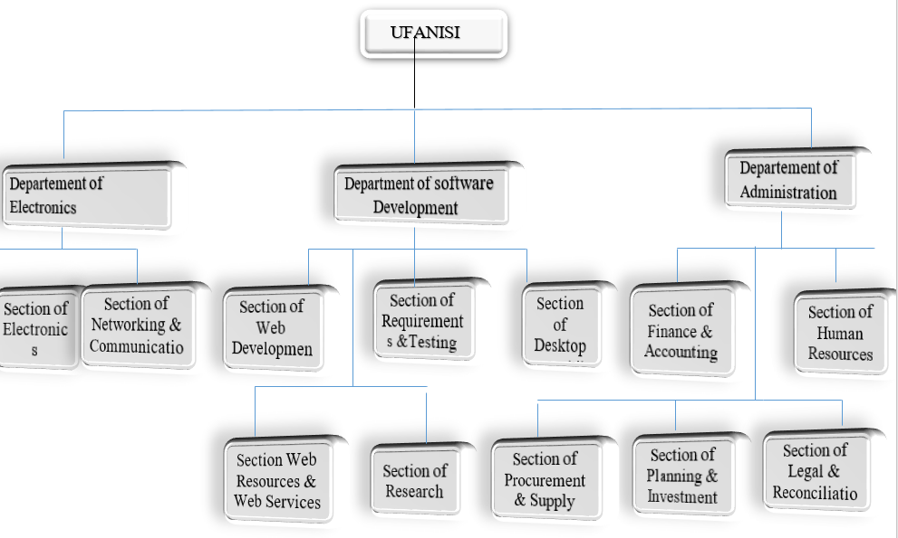

**Figure 1 : Organizational structure of UFANISI ICT**

# CHAPTER III. INTERNSHIP PROGRESS : ANALYSIS AND DESCRIPTION OF THE ACTIVITIES

## III.1. Presentation of the reception service and planning of activities

At my starting days of my internship, first I was welcomed by the staff of UFANISI ICT Solutions and Research (bu) Ltd and after they presented me their different services like: IT service, management service, marketing services and the persons who work within those services.

After the presentation, I was assigned to the IT service as I was a student in IT department and I was given a professional supervisor who will lead and help me during my internship in their company.

The supervisor explained me what kind of works they do in IT service and different tasks they manage usually which are : testing UFANISI applications, advertising, getting client needs and data collection, training, customizing systems according to clients requests.

He showed me their different management systems applications, and gave me a short summary on them and what they really manage.

The first activity I was assigned on was testing applications. I started with the hospital management system as they had a client of that system, on that period.

After I have tested the application, the second activity was to propose different systems to some client companies by sending them proposal documents where it was written the explanation of the system and what it does and how it can help the current company.

If the client was interested about our proposal, the third activity was to present him the system from start to the end and explain him how each modules of the system works. Once finished and if the clients want to purchase our systems, the next step was to establish a document where we write all clients specification and collecting data of the company in order to customize the systems according to the current client needs.

After the developer have finished customizing the application to the current company, the next activity was to add data of the company in the systems so they can start to use it with all data in it.

The final activity was training, which consisted of giving formation to different employees of the current client, in their different departments, on how they will use the application they have bought.

## III.2. Description of the activities performed

The activities I have realized during my internship at UFANISI ICT were : testing applications, marketing or advertising, training, establishing client specifications document.

### ****III.2.1. Testing applications****

The activity of testing an application consisted of studying, understanding and analyzing the functionality of the application.

To better achieve this activity, the first thing to do was to read the documentation of the system you want to test where it is written the objectives of the system, its different modules, what they manage, the cost of the system and other relevant information about the system.

Then, after you could begin the real testing step as you now know what kind of software the system is and what solutions it brings. The next step was to test if what is said in the document is alike in the system and if it’s so, you verify if it works perfectly.

This activity is not done only in order to study the systems, but also continues even when we had a client with one or more application. We continued the testing activity but now not on the prototypes system, but on the customized system of our client and there the testing activity was about to check daily if the client’s specifications are respected and to see if there are no errors in them.

### ****III.2.2. Marketing or advertising****

The activity of marketing and advertising was not totally done in the IT department of UFANISI ICT, but I had chance to participate a short time in the achievement of this activity.

The activity was about to present, explain, advertise and promote their software to companies. This task was somehow difficult because it requires some quality of communication skills for the person assigned to this task.

The presentation and explanation was about to explain the importance of our system and how it can facilitate the company’ daily tasks and to convince the client to purchase the system.

The advertising and promoting steps were done by sending proposal documents of the software and delivering flyers to some companies.

### ****III.2.3. Training****

Introduction to the system, presentation and explanation of the software modules, application configuration, installation and manipulation were lessons that were given to users of the current system in the training activity.

The training activity was given by going to each department of the client company, and every department staff were taught the modules of the applications which only concern them. For example, for hotel management system, cashiers were taught only the part that concern a cashier.

### ****III.2.4. Establishing client’s specifications document****

Every software is built according to users’ needs and all user’s specifications are placed in a document so that they will be considered during the building of the software.

Even if the systems that UFANISI ICT have are applications, which are ready to use, some clients wanted to add others features or to remove modules they do not need.

In that case, my work was to write all those requirements from the clients and submit them to my supervisor so that in turn, he informs the developers of the current system to adapt the application as the client want it to be.

## III.3. Correlation between the theoretical courses and the reality on the ground

During my learning in class, I have seen many courses. Some were theory courses and others were practical courses. In this part, I’m going to analyze some of them and the correlation between the reality on the ground with those courses.

The first course I have applied practical knowledge on the ground is software engineering. In the software Engineering course, we learned software development lifecycle which is the application of standard business practices to building software applications. It's typically divided into six to eight steps: *Planning, Requirements, Design, Build, Document, Test, Deploy, Maintain*. Among those steps, I did apply some of them in practical way on the ground.

The phase of defining requirements is considered part of planning to determine what the application is supposed to do and its requirements. In my case, as the applications were already there, this step was fulfilled by getting client’s specification for their customized system and by defining all the requirements needed to achieve those specifications.

The testing phase helps reduce the number of bugs and glitches that users encounter. This leads to a higher user satisfaction and a better usage rate. Testing application was the core work I was assigned to during my internship.

When we were learning in class this course, the requirement phase seemed easier than it is in practical, where you have a real client and a real system to build. Sometimes client don’t know exactly what they want and it’s hard for them to explain exactly what the need. That can cause some problems during the development because the developer develops the system according to the specifications, and if they are not well defined, it will cause some troubles when arriving to the testing step.

The testing phase is not easy either in the field as we learned in class, because in class, most of the time, we were testing our self-developed applications which were a bit easy because they were not too large and not complex.

Interacting with clients was another task I have performed, which is related with the concepts learned in the course of communication skills.

The programming languages learned in Web programming courses (HTML, CSS, JavaScript, PHP, SQL), were the most used in the development of the applications that UFANISI ICT have.

My observation is that arriving on the ground to apply skills acquired in class is a good way to advance in knowledge for your project.

However, it is not easy because what learned in class, sometimes, is a little different from what is really required on the ground.

I also noticed that the skills learned in class are very fundamental in order to achieve successfully any task, which involves them.

## III.4. Description of the observed problem

As the years go by, the city of Bujumbura continues to grow in population. According to Population Stat world statistical data, in the year 2022, the population of Bujumbura is estimated to 1,139,000 people living in the city.

Everybody wants to live in the capital nowadays. People come from all over the country to live in the city for many reasons : some come to look for a job, others for studies, others to create their own business and many other reasons.

As result, the demand for houses, whether for living or business, is becoming as important as the increase in the city's population and most people turn to renting since few own their own houses.

However, accessing to information on the availability of houses for rent or sale is not very easy to have for people wishing to rent or buy houses in the city of Bujumbura and the same goes for people owning rental houses or wishing to sell them to find potential customers.

Since there are few resources that provide such information, finding a house for rent in Bujumbura is costly (money and time), stressful and tiring task since you will have to turn to several solutions (inquire yourself, contact several commission agents) that are not at all reliable or do not guarantee you to find the house you want and in time.

Following are some difficulties encountered by people looking for a house to rent or to buy :

* The lack of accurate information on the availability of houses for rent or for sale ;
* It costs time and money ;
* Many houses’ visits due to the lack of the accurate information about the house before the visit.

## III.5. Analysis and criticism of the existing system

To my knowledge, in Bujumbura, there are not many solutions helping house seekers or house owners to find easily what they are looking for.

If a person wants to find a house to rent or to buy he has the following possibilities : ask friends if they know houses that are for rent or for sale, or seek for the help of people called commission agents who help people to find houses to rent or to buy.

In the case of people owning houses for rent or to purchase, the solutions that are offered to them are almost the same : they can also ask for the help of commission agents to find customers, or post posters everywhere informing that their houses are for rent with contact details which is not a very reliable and profitable solution since it plays on chance.

The most known and used solution by the inhabitants of the city is the one with commission agents, which consists of the commission agent finding the house for you and you paying him for his service.

Therefore, all these solutions mentioned above are not very reliable and do not provide the desired results and have some disadvantages :

* Most of these commission agents do not have a professional physical address so even finding one becomes a bit difficult.
* Knowing that in Burundi there is not yet a written legislation on the practice of commission agents, the type of contract between him and his clients is random and if you get scammed, you will not be able to complain anywhere.
* It is expensive since all the steps (contact the commission agent, check the house, paying the commission agent) require money.
* By force of spending or being too impatient, the client often ends up accepting to rent a house that is not convenient for him.

## III.6. Proposed solutions to the problem

Having seen these problems that people looking for rental houses and house owners encounter to find potential customers, I would propose a solution that is a Web application that will help the concerned in the following way :

* **For the house holders :**
* Publish their houses (with all necessary information) and let people know that their house is available for sale or rent ;
* Manage their houses on the system.
* **For people that are looking for a house to rent or to buy:**
* Find the house you want through the search engine;
* Discuss in real time with the owner ;
* Ask for a booking or a purchasing for a house ;
* Continue and finish the transaction in real world if the discussion with the owner goes well.

# CHAPTER IV. MODELING OF THE PROPOSED SYSTEM WITH UML AND PRESENTATION OF THE DEVELOPED APPLICATION

## IV.1. Introduction

In this chapter, I will make an overview of the system modeling language UML that I used to present graphically some tasks of the system. I will also present some of UML diagrams that I built.

## IV.2. Explanation of the choice of UML

Unified Modeling Language (UML) is a general purpose modelling language. The main aim of UML is to define a standard way to visualize the way a system has been designed.

We use UML diagrams to portray the behavior and structure of a system. UML helps software engineers, businessmen and system architects with modeling, design and analysis.

While UML is not a [programming language](https://www.indeed.com/career-advice/career-development/functional-programming-languages), it can provide visual representations that help software developers better understand potential outcomes or errors in programs. This may save time and enhancing collaboration among members of a team.

## IV.3. Advantages of UML

* It is flexible and well known : UML diagrams are commonly used to explain software design models. As a result, most software professionals will at least be familiar with them, if not well versed in them.
* Helps to plan a program before the programming takes place.
* Readability and Re-usability of UML Tools : a UML diagram is well readable because it is meant to be understood by any programmer, and it explains program relationships straightforwardly and understandably.

## IV.4. Abstract of certain diagrams

### IV.4.1. Use case diagram

A use case diagram is a way to summarize details of a system and the users within that system. It is generally shown as a graphic depiction of interactions among different elements in a system.

Use case diagrams will specify the events in a system and how those events flow. It describes interaction between users and the system.

### IV.4.2. Class diagram

Class diagrams are one of the most useful types of diagrams in UML as they clearlymap out the structure of a particular system by modeling its classes, attributes, operations, and relationships between objects.

### IV.4.3. Activity diagram

In UML, an activity diagram provides a view of the behavior of a system by describing the sequence of actions in a process.

## IV.5. Modeling of the proposed system

### IV.5.1. Presentation of the use case diagram

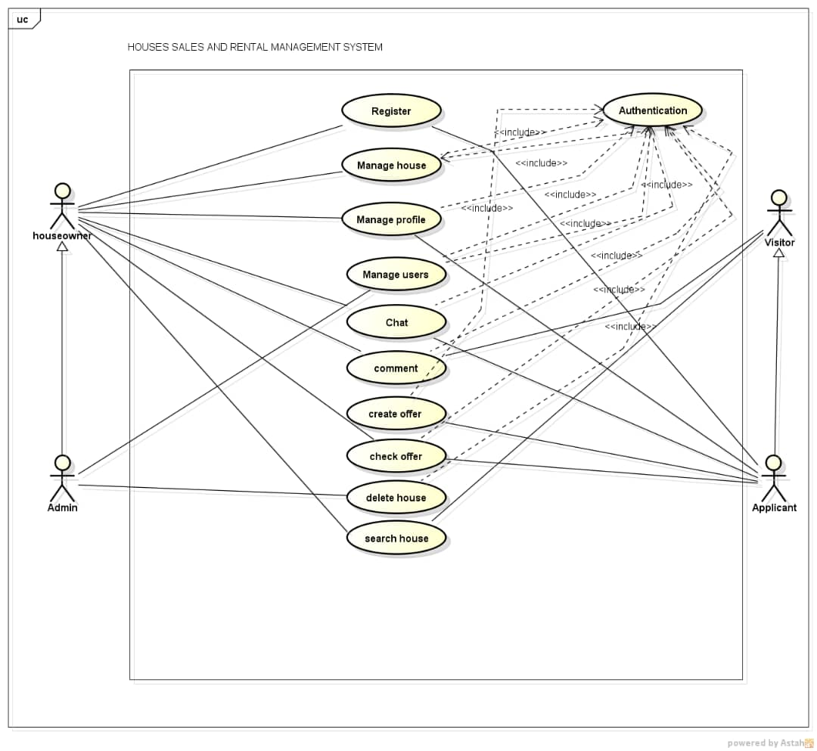

**Figure 2 : Use case diagram**

### IV.5.2. Textual description of the use cases

**Table 1** : **System actors and their roles**

|  |  |
| --- | --- |
| **Actors** | **Roles** |
| Seller / landlord | Add new property, manage his property, discussion, receive offer rental request (accept or refuse) |
| Applicant / buyer | Send messages , send rental offer request |
| Visitor (user without an account ) | View properties, add comment, search for properties |
| Administrator | Manage all the system |

As we have many use cases, we will consider only few use cases for the textual description.

* **Use case : Add property**
* Objective : this use case allows the users to specify the details of their properties.
* Actors : this user case concern only users who wish to rent or sell their properties : **seller/landlords**.
* **Preconditions : the system is launched, the user has the right identifiers.**
* **Nominal scenario : see Table 2.**

**Table 2 :** **Nominal scenario of Add property user case**

|  |  |
| --- | --- |
| **Actor** | **System** |
| 1. **User asks for add property page** | 1. **The system shows the add property form** |
| 1. **The user fill the form and submit** | 1. **The property is added and the system show a successful message** |

* **Alternative scenario : if the user complete wrong data when filling the add property form, he will be returned to the second step of nominal scenario.**
* **Use case : Register**
* Objective : this use case allows the new user to create an account and register into the application.
* Actors : this user case concern every person who wish to register : **visitor.**
* **Preconditions: the system is launched.**
* **Nominal scenario : see Table 3.**

Table 3 : ****Nominal scenario of register user case****

|  |  |
| --- | --- |
| **Actor** | **System** |
| 1. **User asks for register page** | 1. **The system shows the register form** |
| 1. **The user fills the form and submit** | 1. **The user account is created and the system show a successful message and redirect the user to the home page** |

* Alternative scenario : **If the data entered by the user is incorrect, the account is not created and the system display a wrong message and ask the user to retry again.**

### IV.5.3. Presentation of the class diagram

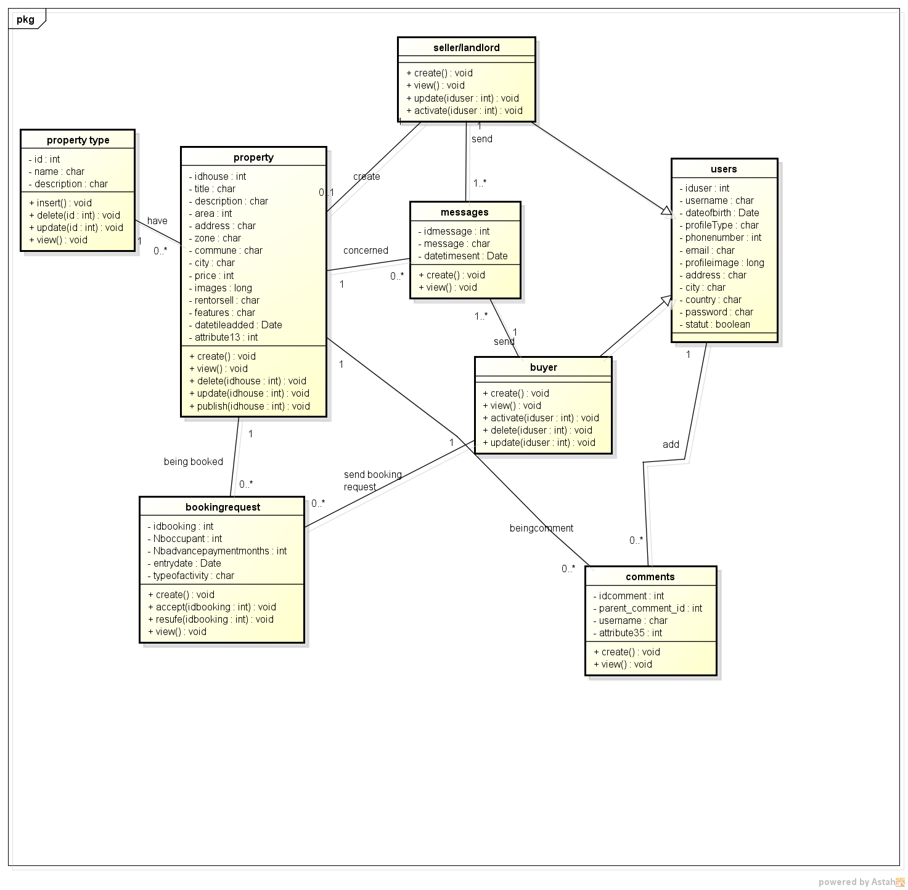

**Figure 3 : Class diagram**

### IV.5.4. Presentation of Activity diagram

* **Activity diagram for Login use case**

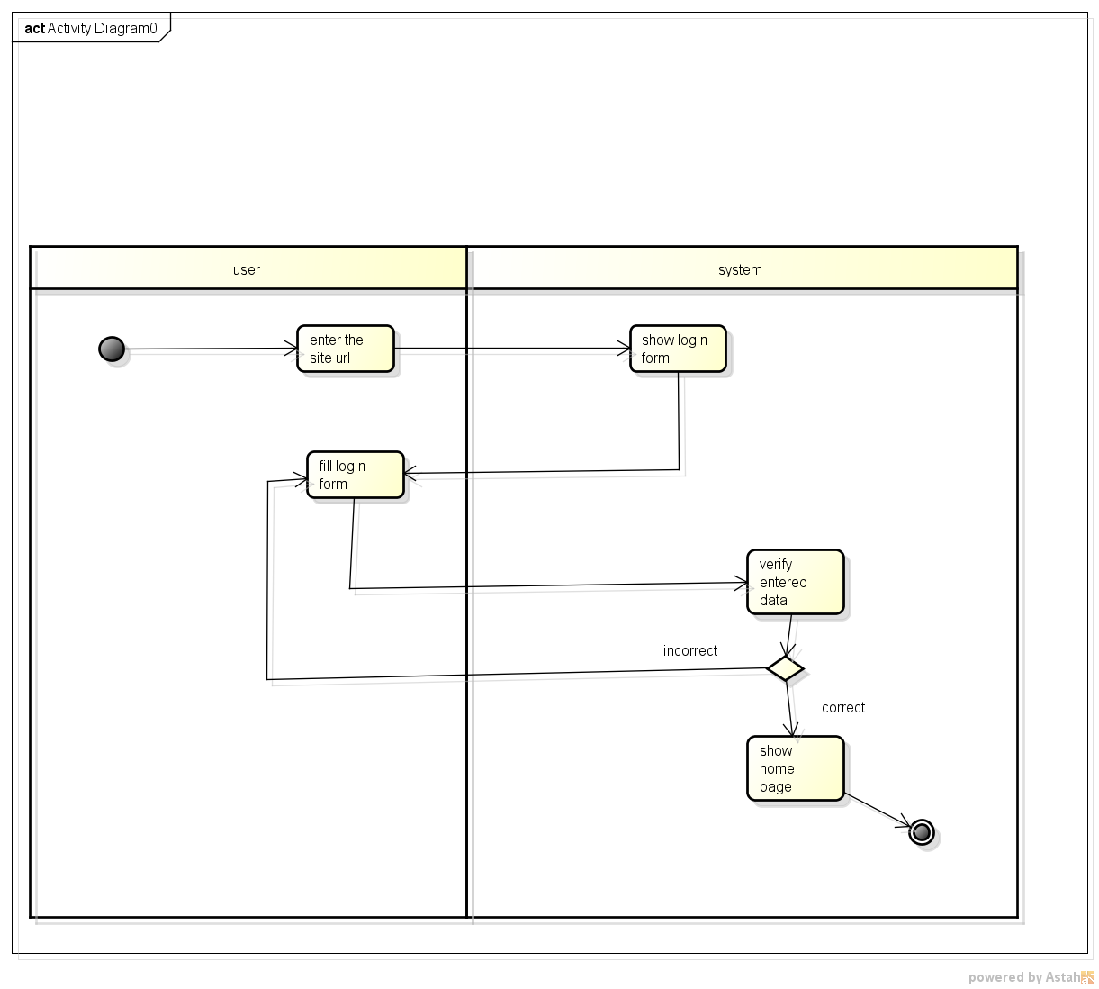

**Figure 4 : Activity diagram for Login use case**

* **Activity diagram for Add property use case**



**Figure 5 : Activity diagram for Add property use case**

## IV.6. Application presentation

### V.6.1. Used tools

For the implementation of the management system of sales and rentals of houses, which is a Web application, I used different hardware and software tools, as well as different programming languages and technologies.

* **Hardware**

For the hardware equipment, I used a Personal Computer with the following characteristics :

* Intel(R) Core(TM) i7-2620M CPU @ 2.70GHz ;
* 4GB of RAM ;
* 500GB hard drive capacity ;
* 64 bits operating system, x64 processor.
* **Software**
* **Visual Studio Code**

Visual Studio Code, also commonly referred to as VS Code, is a source-code editor made by Microsoft for Windows, Linux and Mac. Features include support for debugging, syntax highlighting, intelligent code completion, snippets, code refactoring, and embedded Git. Users can change the theme, keyboard shortcuts, preferences, and install extensions that add additional functionality.

Visual Studio Code is a source-code editor that can be used with a variety of programming languages, including Java, JavaScript, Go, Node.js, Python, C++, C, Rust and Fortran.

* **WAMPServer**

WAMP is an acronym that stands for Windows, Apache, MySQL, and PHP. It’s a software stack which means installing WAMP installs [Apache](https://www.hostinger.com/tutorials/what-is-apache), [MySQL](https://www.hostinger.com/tutorials/what-is-mysql), and PHP on your operating system (Windows in the case of WAMP).

WampServer (formerly WAMP5) is a WAMP-like web development platform, allowing to run locally (without having to connect to an external server) PHP scripts.

WampServer is not in itself a software, but an environment including three servers (Apache, MySQL and MariaDB), a script interpreter (PHP), as well as phpMyAdmin for the Web administration of MySQL databases.

* **Astah Community**

Formerly called Jude, Astah is a UML modeling tool created by the Japanese company ChangeVision1. It works with the Java runtime environment. The name comes from the acronym Java and UML developers' environment.

Astah is a proprietary software that was distributed for free in a "community" version. The software is now subject to a trial period and then to the obligation to buy a user license.

* **Programming languages**
* **HTML**

The Hypertext Markup Language, generally abbreviated HTML or, in its latest version, HTML5, is the markup language designed to represent web pages.

This language allows : to write hypertext, hence its name, to structure the page semantically, to format the content, to create input forms, include multimedia resources such as images, videos, and computer programs, create documents that are interoperable with a wide variety of equipment in a way that complies with web accessibility requirements.

* **CSS**

Cascading Style Sheets, commonly referred to as CSS, is a computer language that describes the presentation of HTML and XML documents.

The standards defining CSS are published by the World Wide Web Consortium (W3C). Introduced in the mid-1990s, CSS became commonly used in web design and well supported by web browsers in the 2000s.

CSS is the language we use to style a Web page. It describes how HTML elements are to be displayed on screen, paper, or in other media.

It also saves a lot of work. It can control the layout of multiple web pages all at once.

* **JavaScript**

JavaScript is a scripting language mainly used in interactive web pages and as such is an essential part of web applications. Along with HTML and CSS, JavaScript is at the heart of the languages used by web developers.

* **AJAX**

AJAX (Asynchronous JavaScript and XML) is not a technology in itself, but a term for a "new" approach using a set of existing technologies, including : HTML or XHTML, CSS, JavaScript, DOM, XML, XSLT, and especially the XMLHttpRequest object.

When these technologies are combined in the AJAX model, web applications are able to perform fast, incremental updates to the user interface without having to reload the entire page in the browser. Applications run faster and are more responsive to user actions.

Although the X in AJAX stands for XML, it is the JSON format that is most often used today instead of XML, because of its proximity to JavaScript and its lightness compared to XML. In other words, both JSON and XML can be used as a format to package data in AJAX.

* **PHP**

Hypertext Preprocessor, better known by its acronym PHP (ancient : Personal Home Page), is a free programming language, mainly used to produce dynamic Web pages via an HTTP server, but which can also function as any locally interpreted language. PHP is an object-oriented imperative language.

* **SQL**

SQL is a standardized computer language used to operate relational databases. The data manipulation part of SQL allows you to search, add, modify or delete data in relational databases.

* **UML**

The Unified Modeling Language is a pictogram-based graphical modeling language designed as a standardized method of visualization in software development and object-oriented design.

* **Bootstrap**

Bootstrap is a free and open-source CSS framework directed at responsive, mobile-first front-end web development. It contains HTML, CSS and JavaScript-based design templates for typography, forms, buttons, navigation, and other interface components.

* **jQuery**

jQuery is a fast, small, and feature-rich JavaScript library. With a combination of versatility and extensibility, jQuery has changed the way that millions of people write JavaScript.

### IV.6.2. Description of the user interfaces

* **Home Page**

When the application is launched, we arrive at the home page where is a menu bar, a search section, about section and a section, which lists latest properties posted, and a contact section.

* **Search section**

This section allows each users utilizing the application to search houses according to their needs on the application.

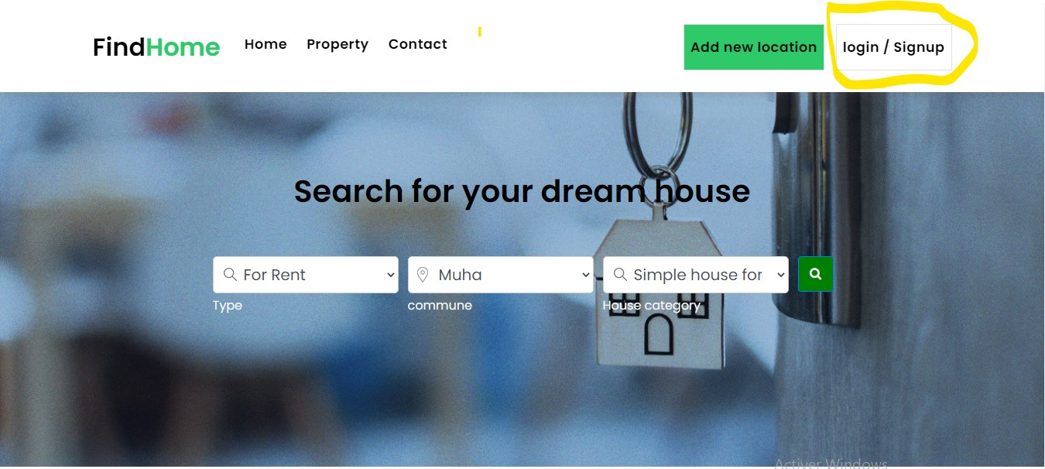

**Figure 6 : Home Page – Search section**

* **Latest properties**

In this section, there is a list of newest properties published on the system. On each post, we can see some few information of the house, a Like button that allows user to like or unlike the house, and a save button which allows users to save the desired houses to avoid having to search for them again.

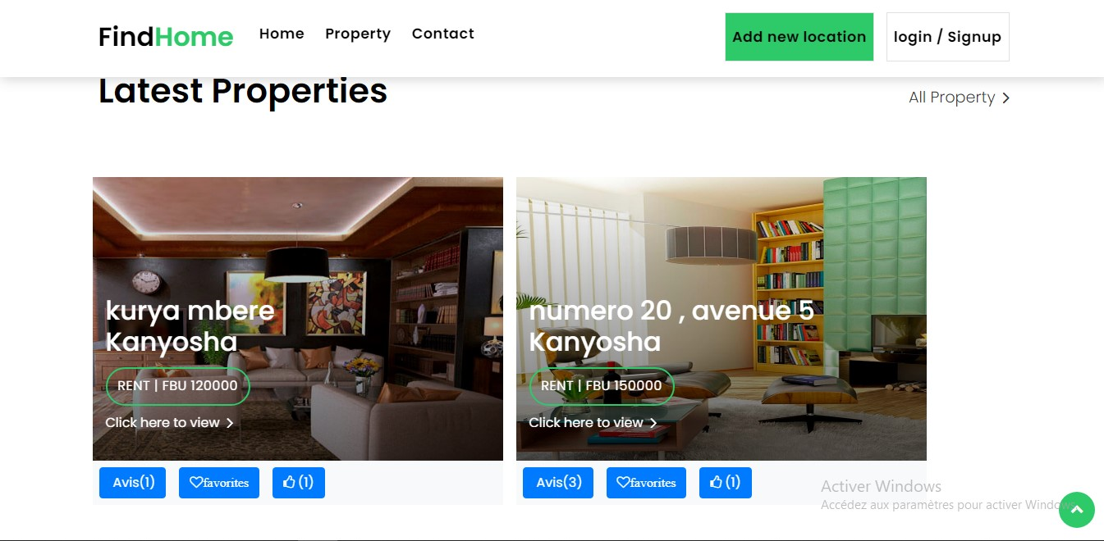

Figure 7 : Home Page - Latest properties section

* **House details page**

The following interface appear when a user clicks on the item (house). It displays information about the clicked house like : images of the property, its area, type of property, address, price, its owner, a comment section to allow the user to add a comment on the house and also a message form section to allow the user to contact directly the owner on the system.

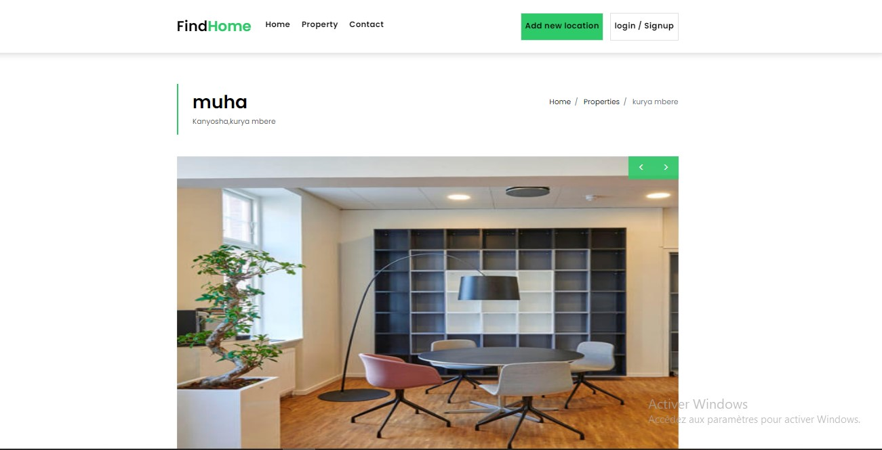

**Figure 8 : House details (1)**

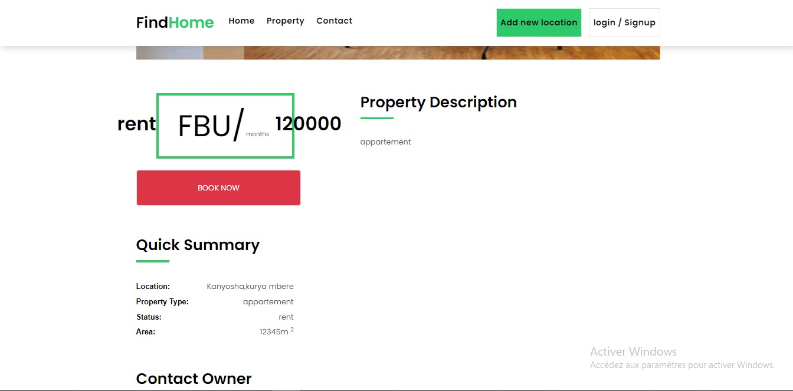

**Figure 9 : Property details (2)**

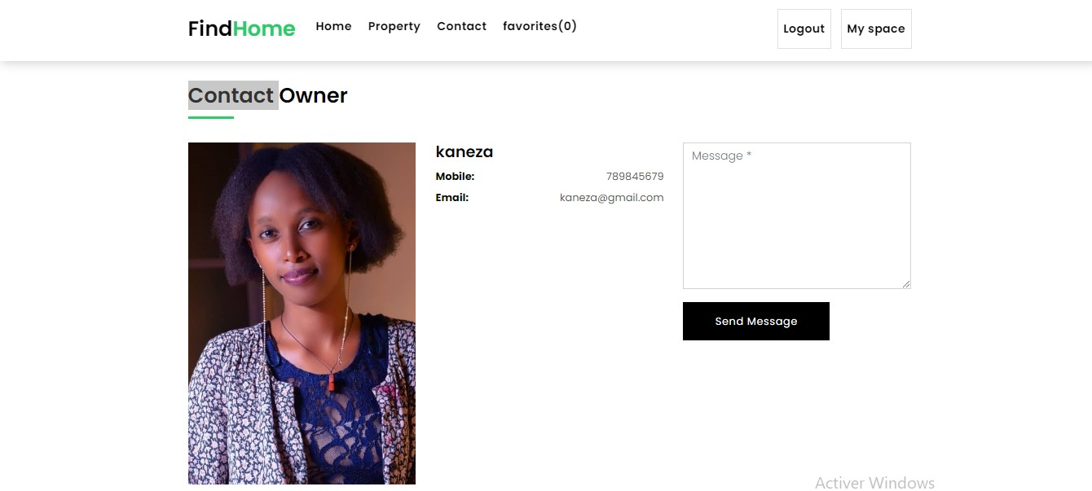

**Figure 10 : Property details (3)**

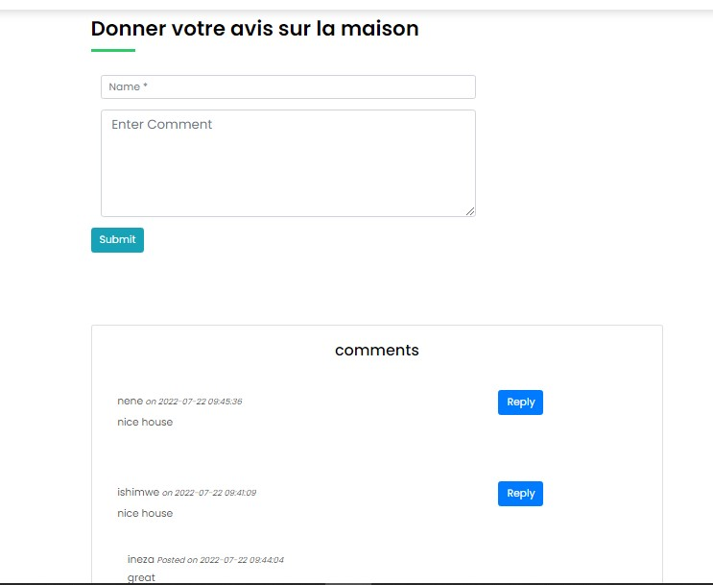

**Figure 11 : Property details (4)**

* **Login Page**

The system allows users to login and for those without account, to register in order to access certain features of the system**.** To login or signup into the application, we click on the “login/signup” button which leads to the signin/signup page.

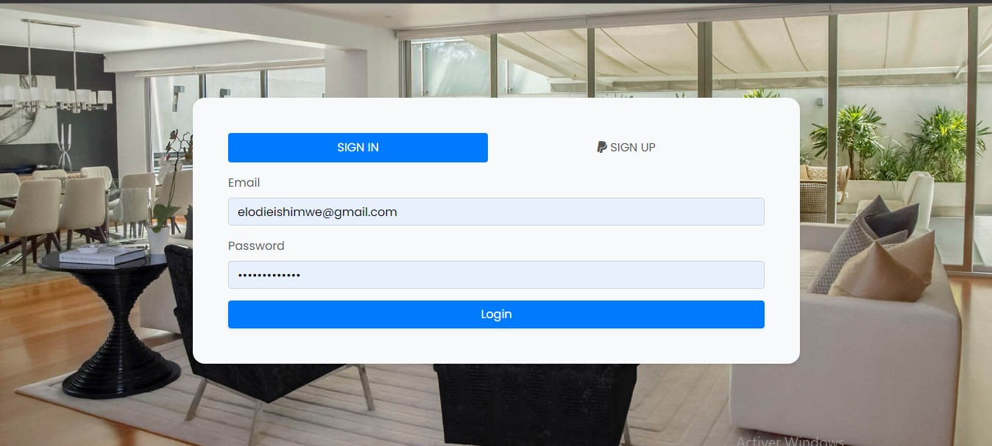

**Figure 12 : Login**

* **Admin interfaces**
* **Dashboard panel**

This interface is the index page of the admin panel. On it, we can see information like numbers of users, number of properties, number of property categories and properties which are not yet published. This page is like an introductory of tasks that are performed by the admin.

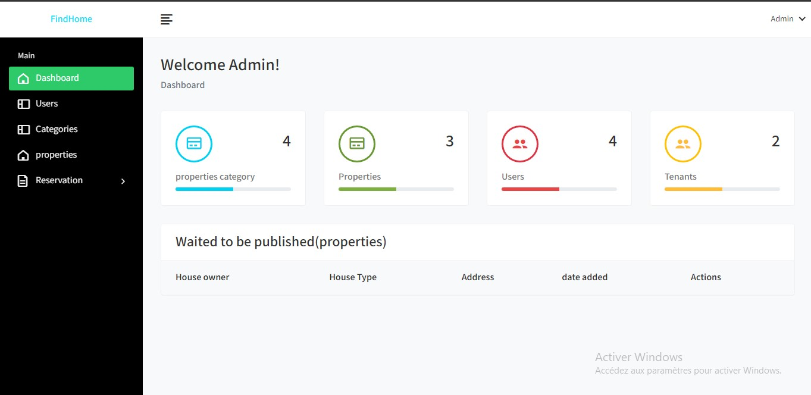

**Figure 13 : Dashboard**

* **Properties management interfaces**

The admin manages all houses existing on the system : he is the one who allow the publication of a house, can delete it or unpublish it.

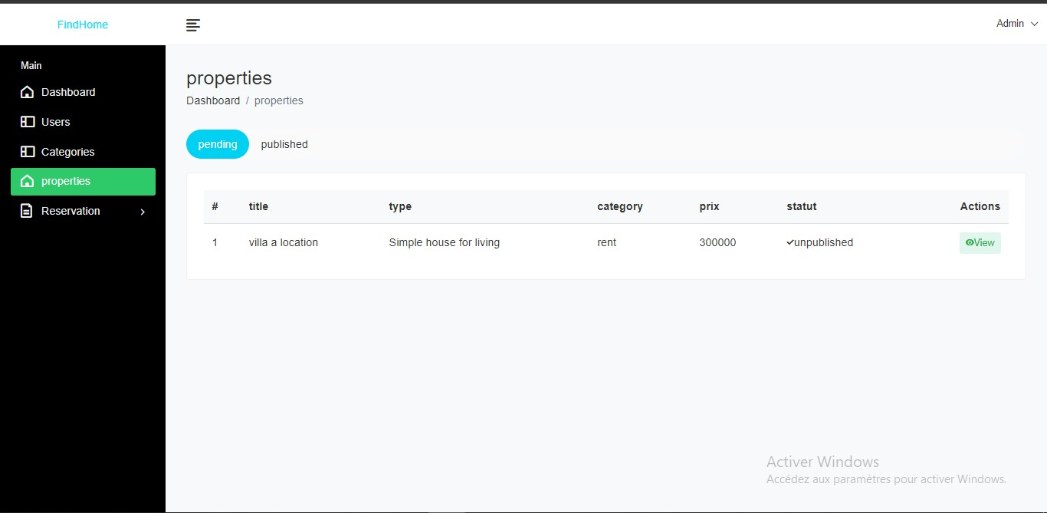

**Figure 14 : Pending property**

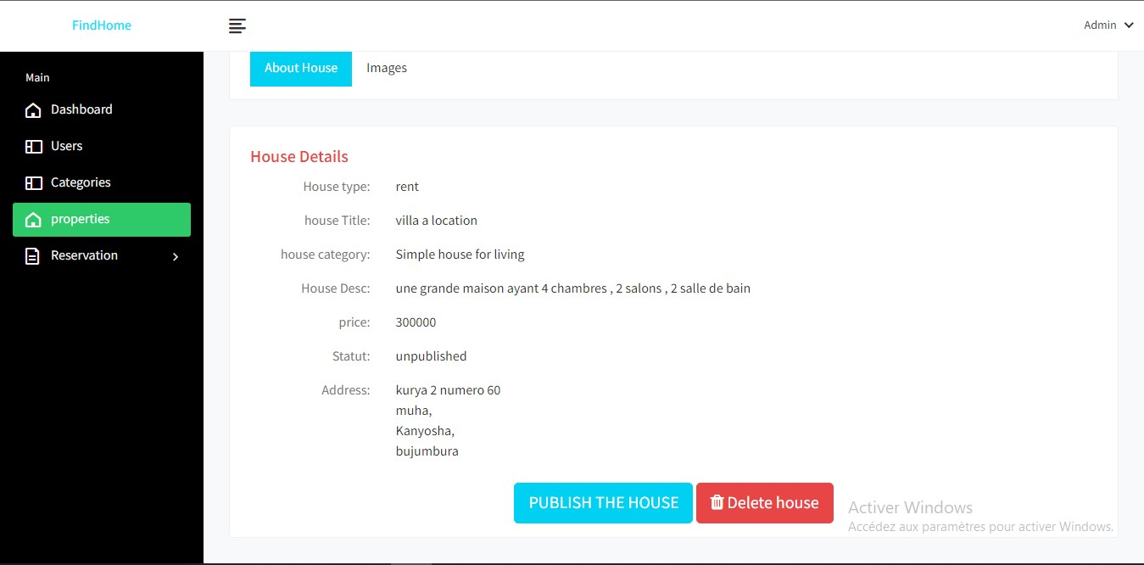

**Figure 15 : House publication**

* **Users management interface**

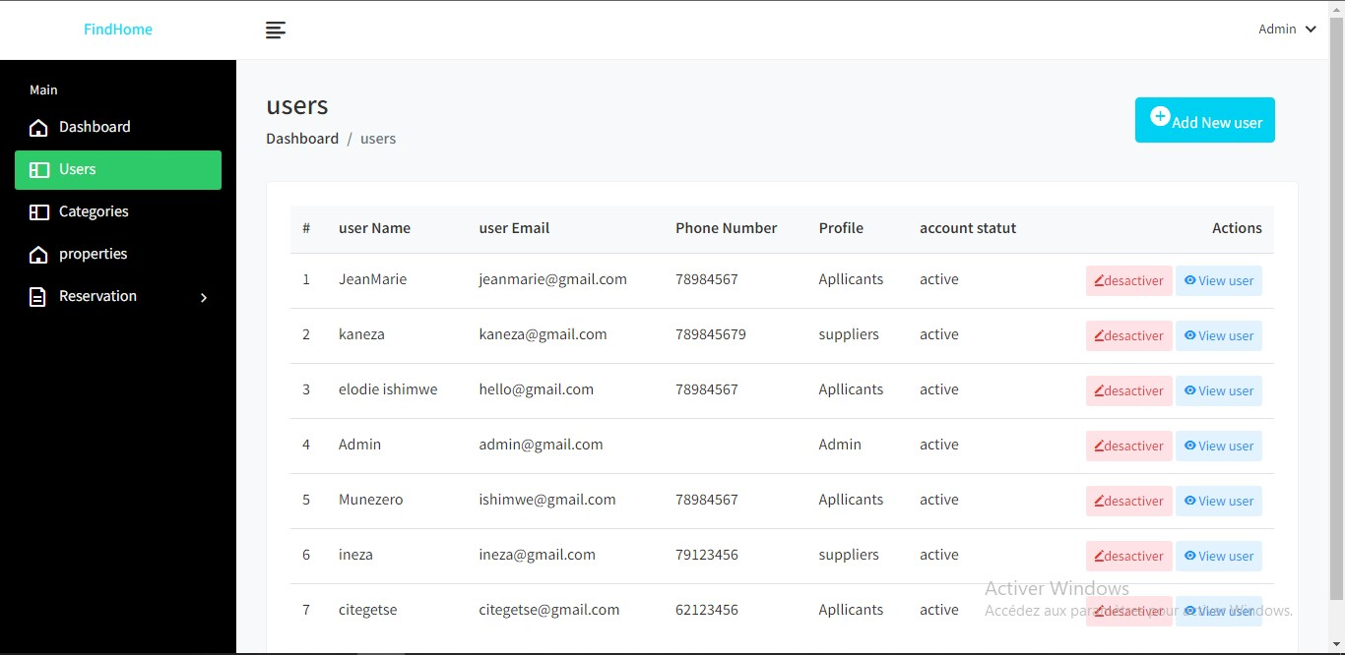

Figure 16 : Users management interface

On this page, the admin view all users of the system, can add a new one through the “add new user button”, can activate or deactivate the users account by clicking the red button and view all users details when clicking the view user button.

* **House owner interfaces**

A user with tenant profile can access several features on the application : he can create a house, edit it and, he can interact with clients though message box and discuss with them, he can see rental offer requests for his listing and accept or refuse them, he can also edit his profile.

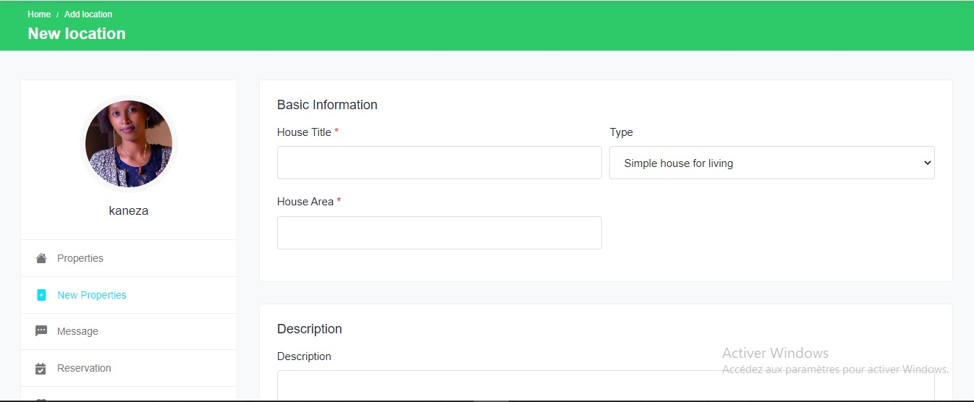

**Figure 17 : New property form**

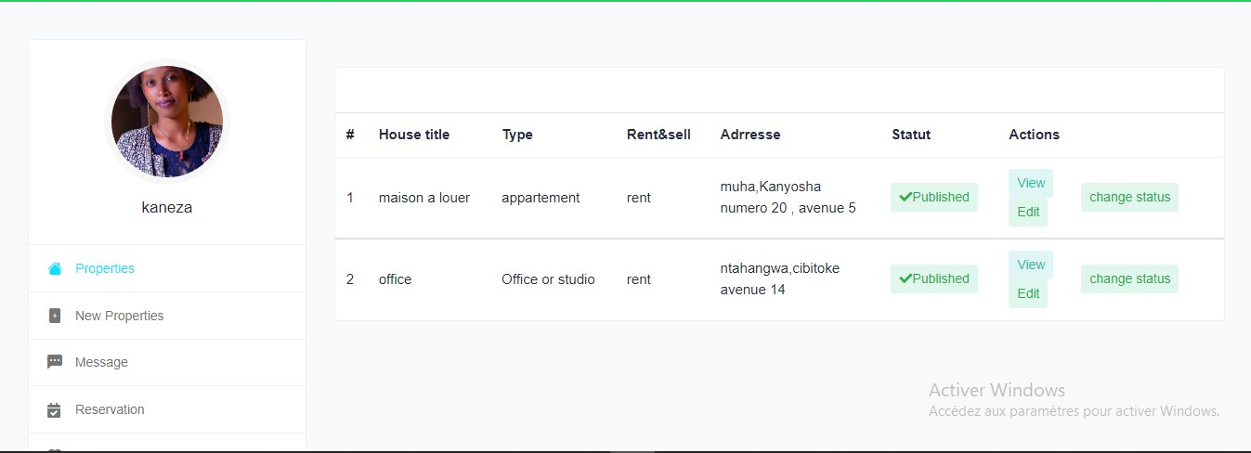

Figure 18 : Property list

The following page is the message page, which lists user’s messages from clients. He can reply them or create a new message.

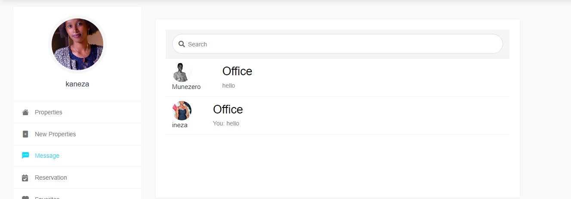

Figure 19 : Message page

On this page, there are all the rental offers of the tenant's house. He can check them, accept or refuse them.

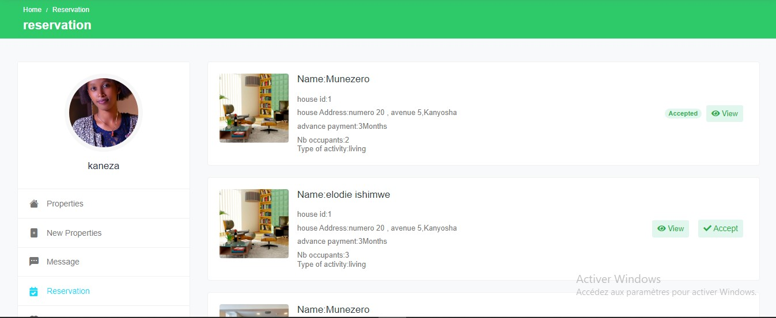

Figure 20 : Offer page

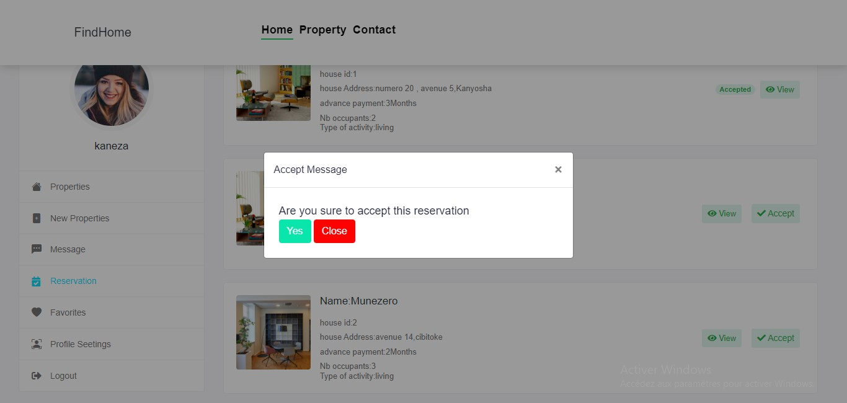

Figure 21 : Accept reservation modal

* **Applicant interfaces**

User with applicant profile can also perform many tasks : view house listings, contact house owner of chosen house through the message box. He can send an rental request offer, check his offers and manage his profile.

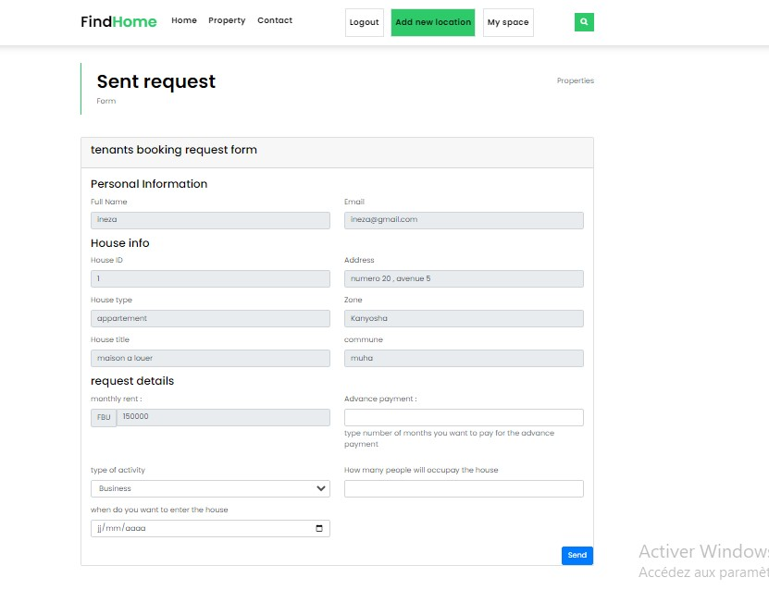

Figure 22 : Rental offer form

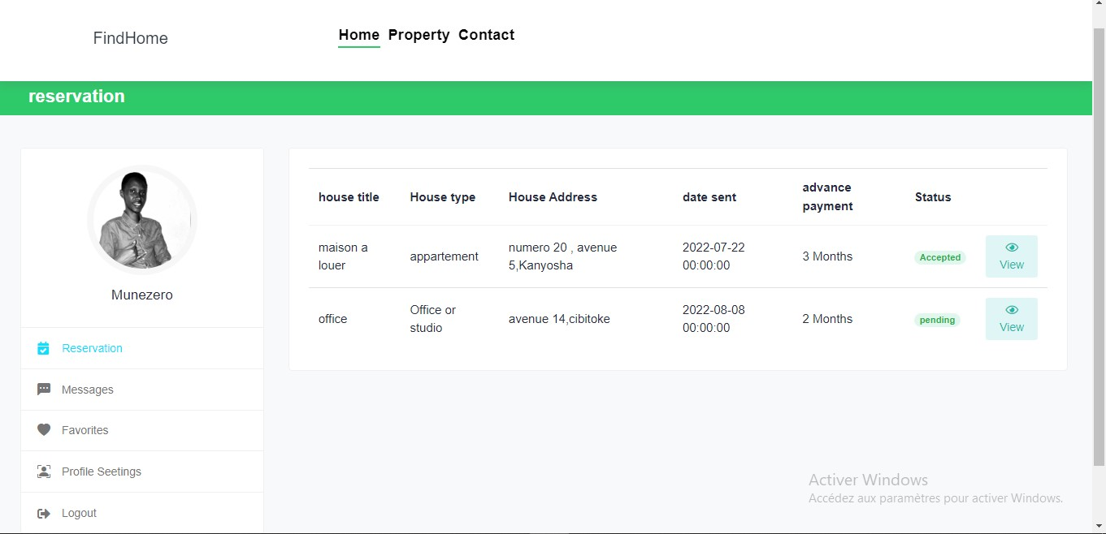

Figure 23 : Check offer status page

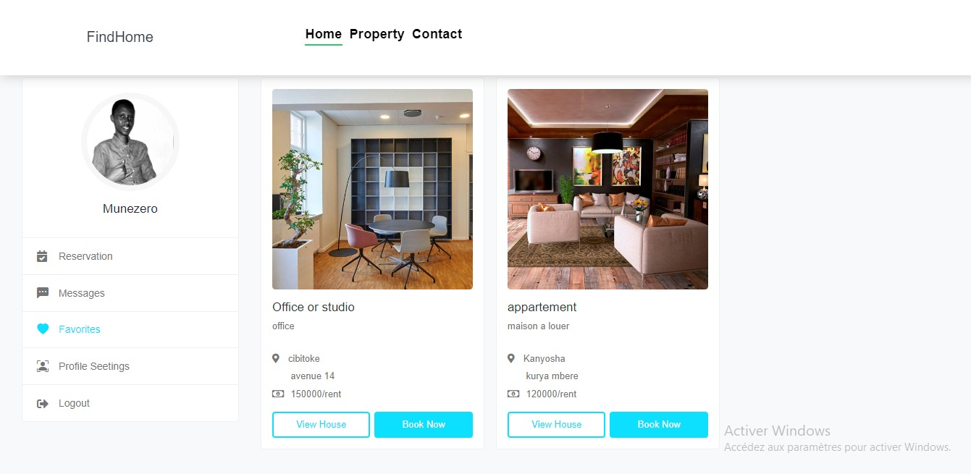

Figure 24 : Favorites page

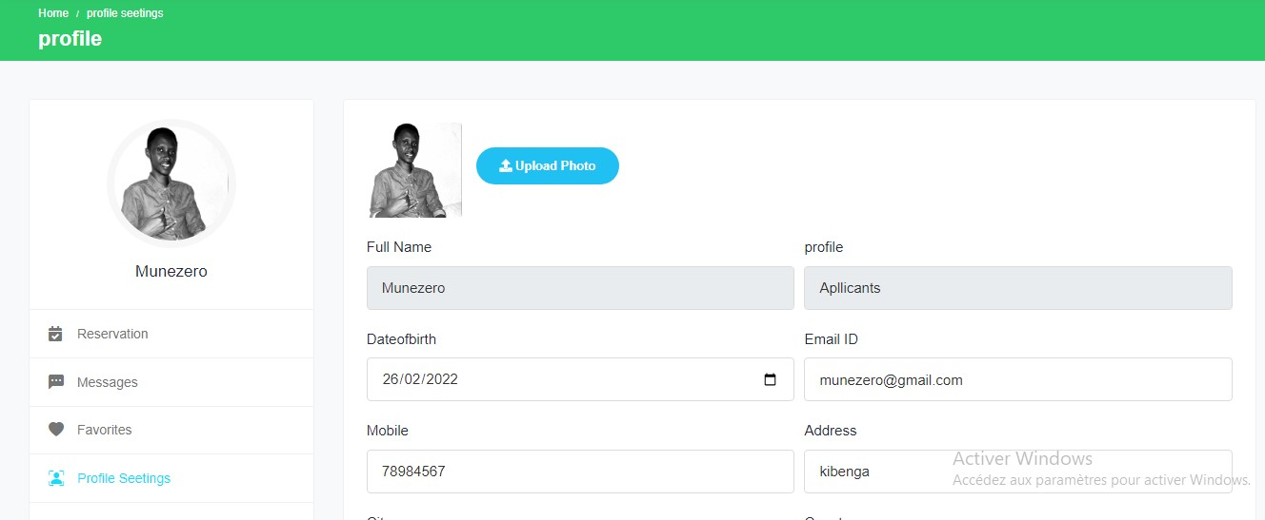

Figure 25 : Profile settings

### IV.6.3. Advantages of the application

The application will help people looking for houses to rent to find what they want easily through the search module, and to obtain the necessary information about them.

It also enables the discussion between the renter and the client, which limits unnecessary visits on the ground and all expenses.

With this application, before you visit the house you have already an overview of what the house looks like, and decide if it’s worth to visit them or not.

The application is interactive and easy to use. Another advantage is that the application is web-based and responsive which means you access to it though Internet and on any device (laptop, smartphone, and tablet) and from everywhere there is Internet.

# CHAPTER V. GENERAL CONCLUSION AND SUGGESTIONS

## V.1. GENERAL CONCLUSION

### V.1.1. Critical appreciation of the progress of the internship

As mentioned in the previous chapters I was able to carry out several activities during my academic internship which I enjoyed so much because it responded to my personal expectations of gaining new skills and experience.

### V.1.2. Critical assessment of the observed problem

The problem observed was the difficulties met by people looking for houses to rent or to buy in the city of Bujumbura.

To solve this problem, I developed a web application that will help on one hand the house owners to market their properties easily and find customers. On the other hand, people looking for houses will find the houses they want easily, and in time.

During the development of this application, I appreciated the efforts I made, the research I did, and even if the application is not totally finished I do appreciate the level it is at this stage.

To make the application more powerful, some extra features could be integrated in the future for example the online payment system that will make it possible to finish transactions between owners and buyers without needing a real world meeting.

## V.2. SUGGESTIONS

My suggestions are addressed to home seekers, home owners, people who are in the real estate business, and to future students of BIU (or any other researcher).

* **For home seekers :**
* To use this application because it is reliable and can facilitate their task in their search for a house ;
* To give their opinions and suggestions on the application.
* **For the owners of houses for rent or sell :**
* To have their properties registered in the system in order to facilitate the whole process of renting or selling their properties.
* **For People operating in the real estate business :**
* To be open to innovation and to start seriously considering the use of such systems.
* **For future students of BIU (or any other researcher)**
* Improve the application by adding other advanced features like integrated online payment, GPS, video chat, instant calls, SMS, etc.

# REFERENCES

**INTERNSHIP REPORTS :**

[1] NSHIMIYIMANA Abel and NSENGIYUMVA Jonathan, « Mise en place d’un système de location en ligne eu Burundi accessible via une application web et mobile », INITELEMATIQUE, BUJUMBURA, JULY, 2019.

[2] NTAKARUTIMANA Elysée and MIRINDI Josué, « Conception d’une plateforme de suivi d’un étudiant dans son environnement éducatif », INITELEMATIQUE, BUJUMBURA, FEBRUARY, 2020.

**WEBSITES :**

[3] <https://en.wikipedia.org/>, consulted several times.

[4] <https://www.hostinger.com/>, consulted on 12 July 2022.

[5] <https://www.w3schools.com/>, consulted several times.

[6] <https://developer.mozilla.org/>, consulted on 24 June 2022.

[7] <https://populationstat.com/>, consulted on 30 August 2022.

[8] https://code.visualstudio.com/, consulted on 14 July 2022.